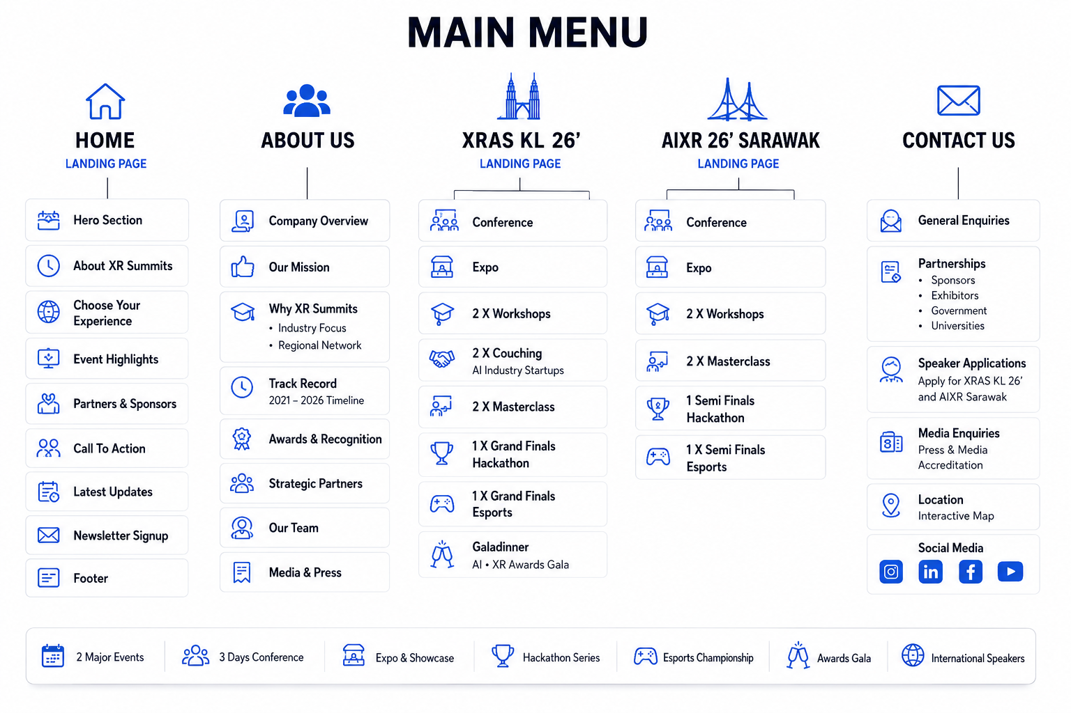HOME

Hero Section
“The Internet was Flat. The Future is Spatial. Powered by AI.”

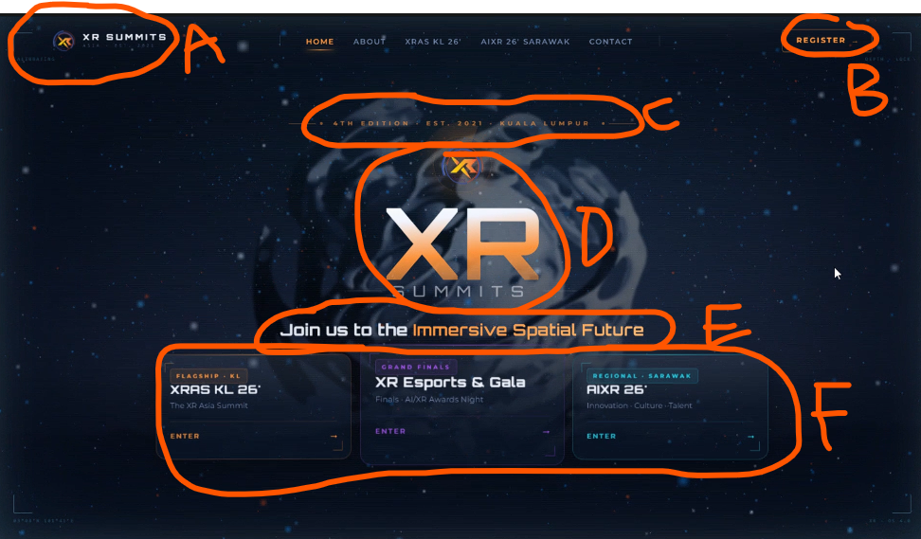 | A = XR Summits Logo and “XR Summits” text only. Please remove the tiny text below it. Enlarge the logo, ensure all elements of logo are visible clearly as the background is dark  B = replace with “Join Us”. mailto: register@xr-summits.com  C = The future will not be viewed. It will be experienced.  D = Can we have like our logo spinning around instead of any text? If it doesn’t look good or something let me know, maybe use bold XR Summits with our fonts  E = This is the Next Phase where Asia Builds Its Spatial Future.  F = 3 gateways  - XR Asia Summits  - AI-XR Cultural Innovation Forum  - AI Filmmaking Hackathon  “Or scroll for more” replace with “Experience More”

About XR Summits
XR Summits Sdn Bhd is the definitive platform connecting innovators across Extended Reality (XR), Spatial Media, AVXR, immersive technologies, and the evolving future of esports. It serves as the region’s central hub for showcasing production-ready solutions and forging high-value commercial partnerships. XR Summits represents a decisive shift in the immersive industry.

"Deployment Ready. Innovation in Action. Reality Redefined".

500+ Industry Leaders
40+ Expert Speakers
4 Years of Excellence

- Premier Event Organiser
XR Summits is the leading platform for immersive XR technology, bringing together visionaries in Virtual Production, XR technology, and Immersive tech.
- World-Class Masterclass
Learn from industry experts through our comprehensive masterclass programs covering XR & AI, and cutting-edge virtual production techniques.
- Global XR Community
Connect with brilliant minds and exceptional leaders who share first-hand experiences, invaluable insights, and expert advice on implementing immersive XR programs.

Choose Your Experience
4th XR Asia Summits 2026
1 - 3 December 2026
Malaysia International Trade and Exhibition Centre
CTA button “Join the Movement” → mailto: register@xr-summits.com
AI-XR Cultural Innovation Forum
16 - 17 October 2026
Borneo Convention Centre Kuching (BCCK)
CTA button “Join the Movement” → mailto: register@xr-summits.com
AI Filmmaking Hackathon
CTA button “Join the Movement” → mailto: register@xr-summits.com

Past Event Highlights

(pic attached PLACEHOLDER) | XR Asia Summit 2021  25 - 27 November 2021 - 100+ Attendees
2nd XR Asia Summit 2022  11 - 13 November 2022 - 200+ Attendees  The 2nd XR Asia Summits was a dynamic gathering that brought together leading minds and influencers in the Extended Reality industry, featuring an innovative XR solutions showcase, hands-on workshops, and engaging sessions that provided participants with the opportunity to explore cutting-edge technologies, exchange insights, and expand their professional network — leaving attendees inspired and eager to embrace the future of XR. | (pic attached)
(pic attached) | 3rd XR Asia Summit 2023  27 - 29 September 2023 - 500+ Attendees  The 3rd XR Asia Summits brought together leading experts and visionaries across Virtual Production, XR technology, and immersive tech. Held as part of the Malaysia Digital Content Festival 2023, the Summit's Conference, Workshops, and Expo was a joint collaboration between Broadcast Elements Sdn Bhd and the Malaysia Digital Economy Corporation (MDEC), reinforcing its position as a premier platform for driving innovation and industry collaboration within the XR ecosystem.

1,430+ Total Attendees
40+ Total workshops
75+ Partners

Partners & Sponsors

BE XR Studio Concepts
COE
DCC
FINAS
MDEC
POSTAM
___________________

AOTO
Artixium
Aximmetry
Blackcam Robotics
Brompton Technology
Eztrack
Flinders University
Infiled
Korad
Mo-sys
OARO
Object Matrix
Ortana
Panasonic
Smode
Stipe
Unreal
Ventuz
Vivemars
Zero Density

Logo: Attached

Speakers
*pics will be populated soon
Dato’ Kamil Othman  President  FINAS | Nick CG Tan  CEO  Oceanus Media Global | Thi Thu Hien Hoang  CBO  Mirabo Global Company | Alex David  Co-CEO  Tactician Business Gaming
Carl Loo  CEO  Solid Water | Kei Choong  Founder & CEO  Aux Media Ltd | Fariz Hanapiah  Creative Director  Experiential Design Team (EDT) | Justin Wong  CEO  TrueXR
Havene Liew  President  XR Associates (XRA) | Ts. Dr. Mohd Zaliman Mohd Yusof  President  Technology & Digital Creative Association (TDC) | Jason Yim  CEO/Founder  Trigger XR | Dr. Ike Tan  Assoc. Professor, Professional Technologist  Asia Pacific University of Technology and Innovation (APU/APIIT)
Dr. Andrew Yew  CTO  Ministry XR | Hussin Khan  Founder & CEO  EFXCO | Thomas Desmeules  Head of Real-Time Technology  Solotech | Kian Chai Ng  Principal Design Manager  Microsoft

Call to Action
Join the Next Phase Where Asia Builds Its Spatial Future.
Whether you're attending, exhibiting, sponsoring, or speaking, XR Summits connects you to the conversations and partnerships that matter.
Button → “Join the Movement” → mailto: register@xr-summits.com

Footer
Tel: +6012-2020624
Email: register@xr-summits.com

LinkedIn : https://www.linkedin.com/company/xr-summits/posts/?feedView=all
YouTube : http://www.youtube.com/@XR-SUMMITS?sub_confirmation=1
TikTok : https://www.tiktok.com/@xrsummits
Instagram : https://www.instagram.com/xrsummits/
Facebook : https://www.facebook.com/profile.php?id=61583955069948

No. 8, Block K, 8th Floor,
Sunway PJ 51A, Jalan SS9A/19,
47300 Petaling Jaya, Selangor,
Malaysia

Privacy Policy
Privacy policy – Asia's Premier XR Event

Terms & Condition
Terms & Conditions – Asia's Premier XR Event

Refund Policy
Refund Policy – Asia's Premier XR Event

XR SUMMITS SDN BHD, MALAYSIA (1506516-A) ©2026. All Rights Reserved.

ABOUT US

Company Overview
XR Asia Summits (XRAS), founded by Louis Clovis, is a premier AI XR EVENT focused on
the latest advancements in AI, Virtual, Augmented, and Extended Reality (XR). The three-day
summit connects global XR creators and industry leaders, showcasing innovative production techniques and immersive, story-driven content.

The event features live sessions from top global speakers, covering industries such as film,
broadcast, virtual travel, gaming /esports and education. XRAS also offers virtual
networking and presentations, fostering discussions on how XR technology is transforming XR storytelling and shaping the future of immersive experiences.

Our Mission
Double business with half the impact.

Our mission is to advance XR production techniques, foster upskilling opportunities, and highlight case studies on immersive, story-driven content. By connecting top XR creators and industry leaders from around the globe, XR Summits serves as a catalyst for innovation in XR
technology and storytelling via it’s signature event XR Asia Summits.

Connecting industry leaders, creators, educators, broadcasters, governments and technology innovators through deployment-ready immersive experiences.

Why XR Summits
Centralised AI Creation
Efficiently manage all AI content creation from a single, integrated hub.

Flexible & Customisable
Access scalable service tiers that adapt precisely to your evolving project demands.

Expert Support
Benefit from expert creative support and cutting-edge immersive technology integration.

Optimised Productivity
Save valuable time, significantly reduce costs, and dramatically boost overall productivity.

Industry Focus
XR Summits focus on how immersive technologies like Virtual Reality (VR), Augmented Reality (AR), and Extended Reality (XR) are transforming various industries. Key sectors include:

• Film & Broadcast: Virtual sets and real-time effects are revolutionising production.
• Education: XR creates engaging, experiential learning environments.
• Virtual Travel & Tourism: Immersive tools allow virtual exploration of destinations.
• Events & Entertainment: XR enhances live performances and audience interaction.
• Gaming & Esports: XR innovations drive immersive gameplay and competitions.

XR Summits explore the latest trends and innovations across these sectors, showcasing how XR is reshaping industries.

Regional Network

Track Record

Awards & Recognition
The XR Asia Summit is to honor XR content development in Malaysia & Asia regardless of it size or location, which shows excellence in all aspects of their creation. It is also known as the “OSCAR” award for the film, broadcast, gaming and education in AR/VR/XR development. The XR Asia Awards would lead up to be a prestigious award that many content creators desire as a benchmark for excellence in their amazing talent and work. It represents highest accolades and standards of professionalism.

We cordially invite you to join this black-tie event, come to network with industry peers, meet old friends and make new ones while celebrating the achievements of our Winners and Awards Recipients.

WHY ATTEND
The XR Asia Awards ceremony promises to be a brilliant night of celebration, recognising the Asia’s best digital content and creators.
Don’t miss out on your chance to celebrate with your peers, clients and the wider industry by joining us on the night.
We look forward to seeing you on the night and, if you’re entering the awards, wish you the best of luck with your entry.

AWARDS NIGHT
Winning a XR Asia Award is a huge accolade, and the awards night is a massive celebration of your success, showcasing your talents in front of more than 600 of your peers and clients.

WHY ENTER?
The awards celebrate Asia’s very best digital content & creators with focus on emphasising the context of how shows and channels perform.
The judges assess entries based on their understanding of the industry, as well as the resources available to broadcasters and producers.

JUDGING PROCESS
The awards are judged by a panel of more than 10 industry experts, handpicked by the Broadcast team. The judges are split into groups, and each allocated a category.

Strategic Partners

Our Team

Media & Press

XR Asia Summits

Conference

Expo

2x Workshops

2x Coaching

2 x Masterclass

AI Filmmaking Hackathon (Grand Final)

Esports Tournament (Grand Final)

Gala

AI-XR Cultural Innovation Forum

Conference

Expo

2x Workshops

2x Masterclass

AI Filmmaking Hackathon (Semi Final)

Esports Tournament (Semi Final)

CONTACT US

General Enquiries

Partnerships

Sponsors

Exhibitors

Government

Universities

Speaker Applications

Media Enquiries

Location

